Antiprism

Definition
# Source: AI Source: Provided by: [Data Path: Persons Table -> ID Column: 1, Name_En Column: Motasem Essam] -> From: [ChatGPT] on [7/25/2026]
An Antiprism is a three-dimensional polyhedron consisting of two parallel, congruent polygonal bases, with one base rotated relative to the other, and a series of alternating triangular lateral faces connecting their corresponding edges.
An antiprism with regular polygonal bases is called a Regular Antiprism.
Unlike a prism, which has parallelogram-shaped lateral faces, an antiprism has triangular lateral faces.
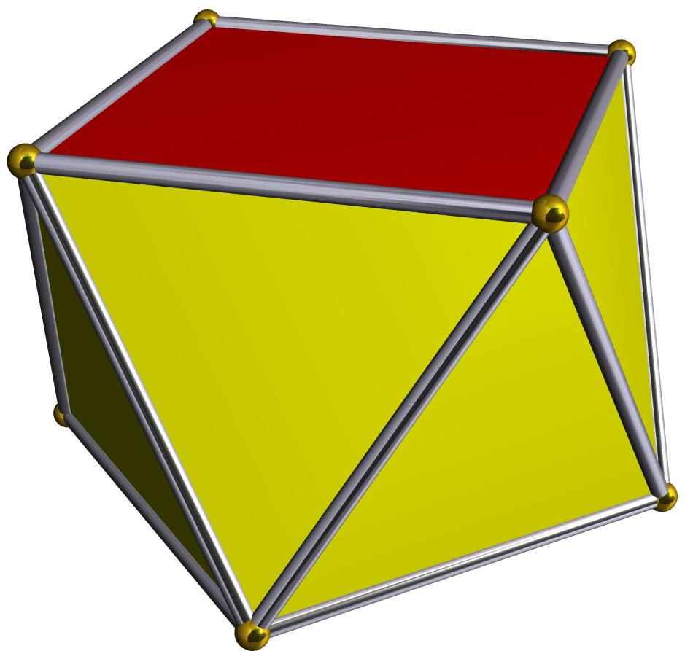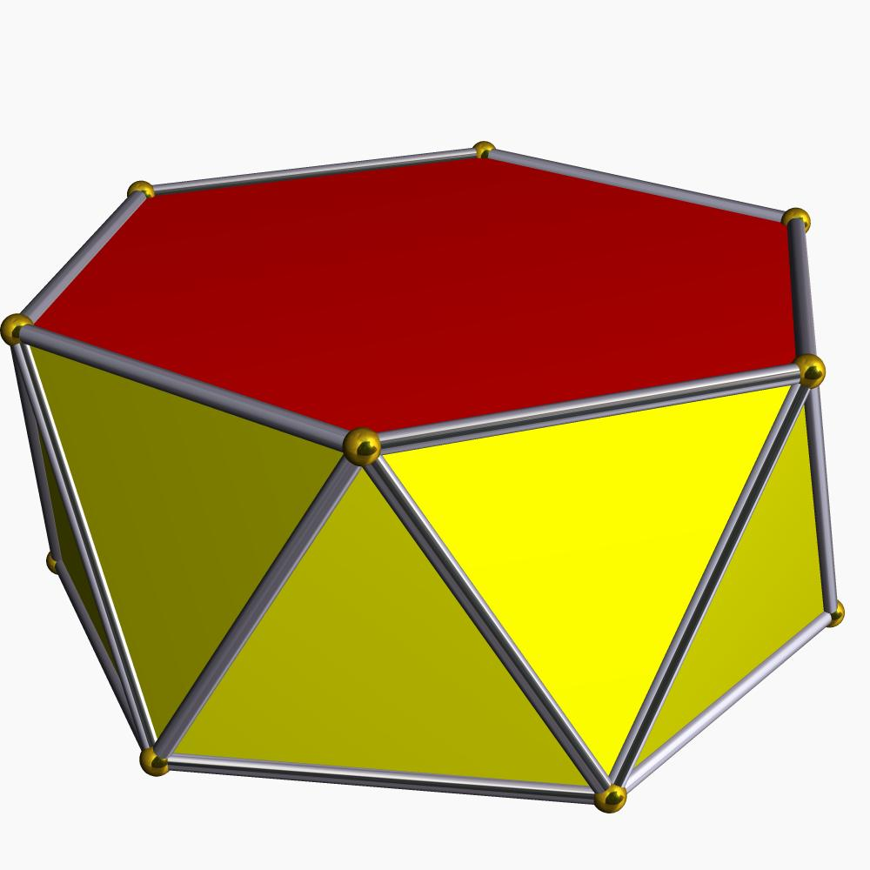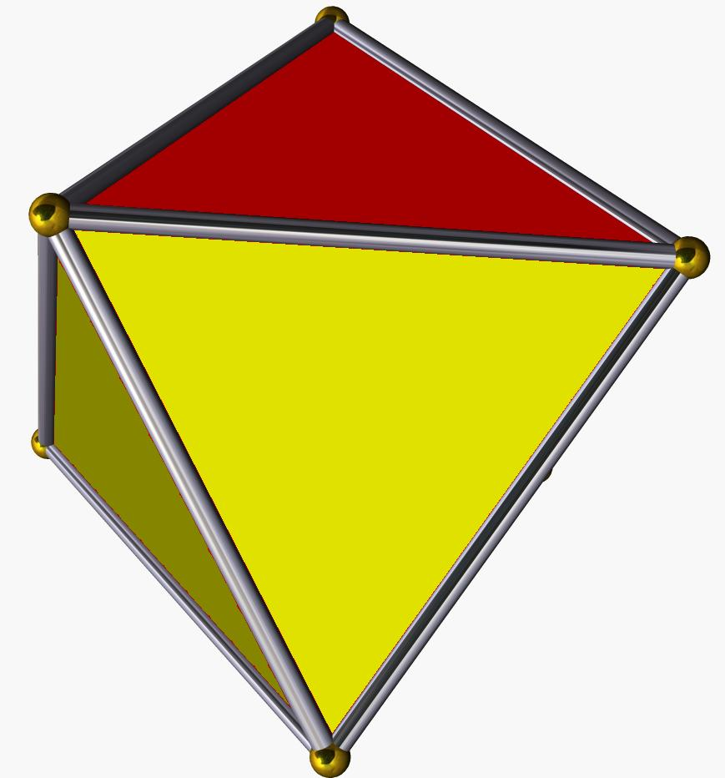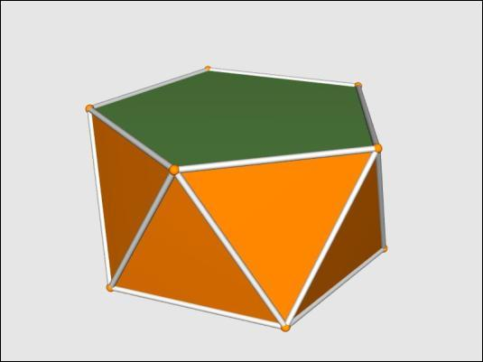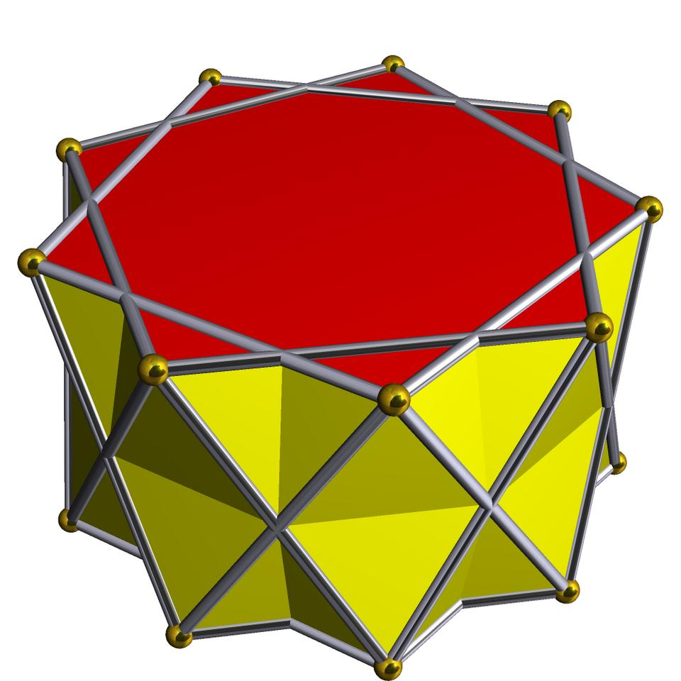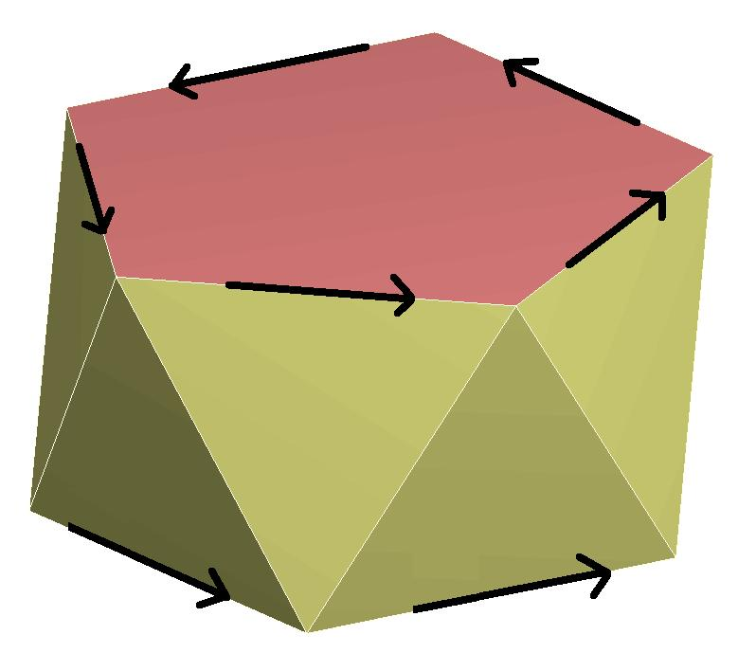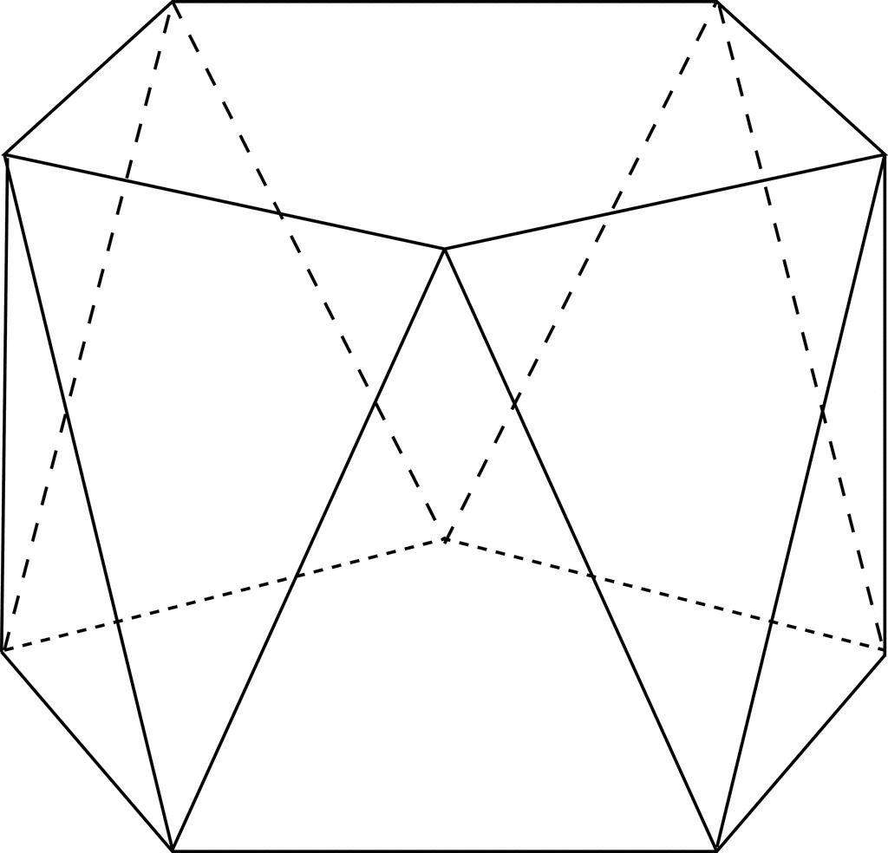

Geometric Structure
# Source: AI Source: Provided by: [Data Path: Persons Table -> ID Column: 1, Name_En Column: Motasem Essam] -> From: [ChatGPT] on [7/25/2026]
An antiprism consists of the following elements:
- Upper Base: A polygon forming the top face.
- Lower Base: A congruent polygon forming the bottom face.
- Rotated Bases: The upper and lower bases are rotated relative to each other, typically by half the central angle between adjacent vertices in a regular antiprism.
- Triangular Lateral Faces: A sequence of triangles connecting the two polygonal bases.
- Vertices: Located around the upper and lower bases.
- Edges: Forming the boundaries of the bases and triangular lateral faces.
For a regular antiprism, the two bases are parallel, congruent, and regular polygons.

Face Composition
# Source: AI Source: Provided by: [Data Path: Persons Table -> ID Column: 1, Name_En Column: Motasem Essam] -> From: [ChatGPT] on [7/25/2026]
An antiprism with $n$-sided polygonal bases contains three main groups of faces.

Upper Polygonal Base
# Source: AI Source: Provided by: [Data Path: Persons Table -> ID Column: 1, Name_En Column: Motasem Essam] -> From: [ChatGPT] on [7/25/2026]
A regular $n$-sided polygon forming the upper face.

Lower Polygonal Base
# Source: AI Source: Provided by: [Data Path: Persons Table -> ID Column: 1, Name_En Column: Motasem Essam] -> From: [ChatGPT] on [7/25/2026]
A congruent regular $n$-sided polygon forming the lower face.
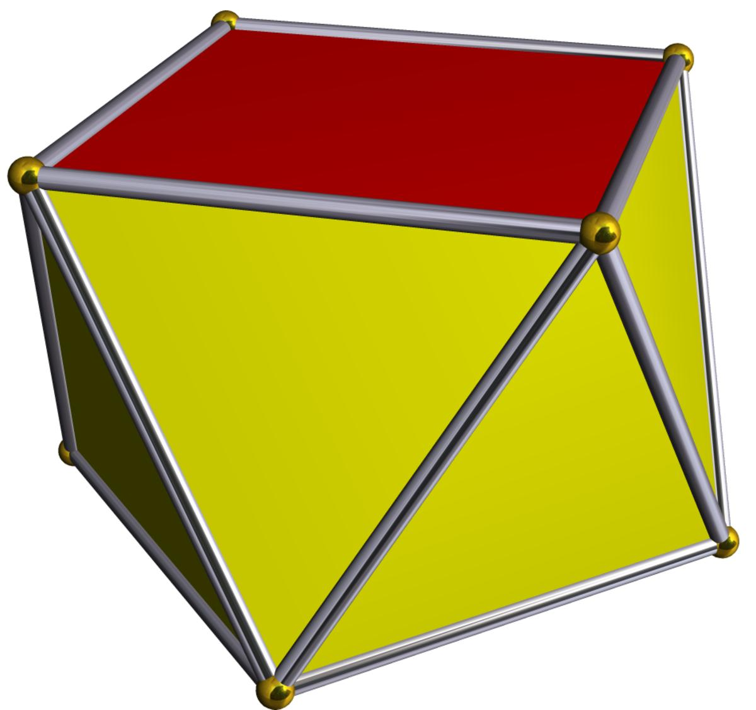

2n Triangular Lateral Faces
# Source: AI Source: Provided by: [Data Path: Persons Table -> ID Column: 1, Name_En Column: Motasem Essam] -> From: [ChatGPT] on [7/25/2026]
Alternating triangular faces connecting the upper and lower bases.
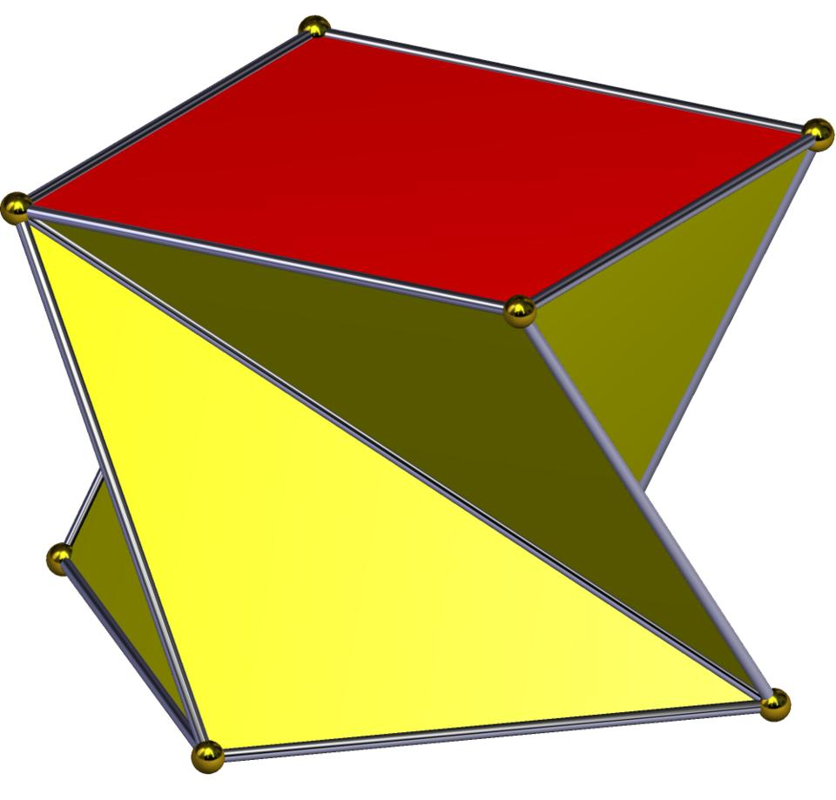
Total face composition:
- 2 Polygonal Faces.
- $2n$ Triangular Faces.
- $2n+2$ Faces in total.

Mathematical Properties
# Source: AI Source: Provided by: [Data Path: Persons Table -> ID Column: 1, Name_En Column: Motasem Essam] -> From: [ChatGPT] on [7/25/2026]
For an antiprism with two regular $n$-sided bases:
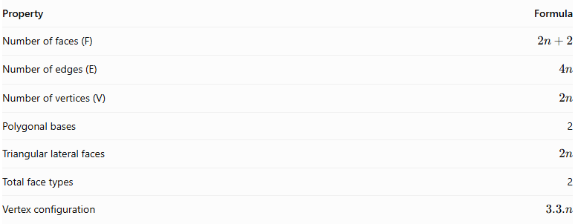
Property | Formula
Number of faces (F) | $$2n+2$$
Number of edges (E) | $$4n$$
Number of vertices (V) | $$2n$$
Polygonal bases | 2
Triangular lateral faces | $$2n$$
Total face types | 2
Vertex configuration | $$3.3.n$$
Euler's Formula
$$V-E+F=2$$
Substituting the formulas:
$$2n-4n+(2n+2)=2$$
Examples of Antiprisms
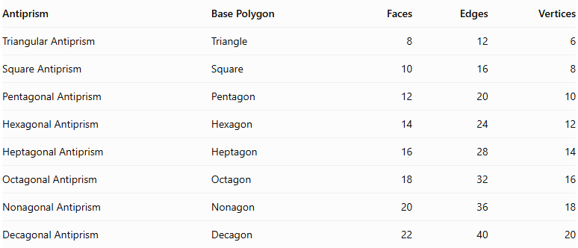
Antiprism | Base Polygon | Faces | Edges | Vertices
Triangular Antiprism | Triangle | 8 | 12 | 6
Square Antiprism | Square | 10 | 16 | 8
Pentagonal Antiprism | Pentagon | 12 | 20 | 10
Hexagonal Antiprism | Hexagon | 14 | 24 | 12
Heptagonal Antiprism | Heptagon | 16 | 28 | 14
Octagonal Antiprism | Octagon | 18 | 32 | 16
Nonagonal Antiprism | Nonagon | 20 | 36 | 18
Decagonal Antiprism | Decagon | 22 | 40 | 20

Types of Antiprisms
# Source: AI Source: Provided by: [Data Path: Persons Table -> ID Column: 1, Name_En Column: Motasem Essam] -> From: [ChatGPT] on [7/25/2026]
Antiprisms can be classified according to the polygonal shape of their bases.

Triangular Antiprism
# Source: AI Source: Provided by: [Data Path: Persons Table -> ID Column: 1, Name_En Column: Motasem Essam] -> From: [ChatGPT] on [7/25/2026]
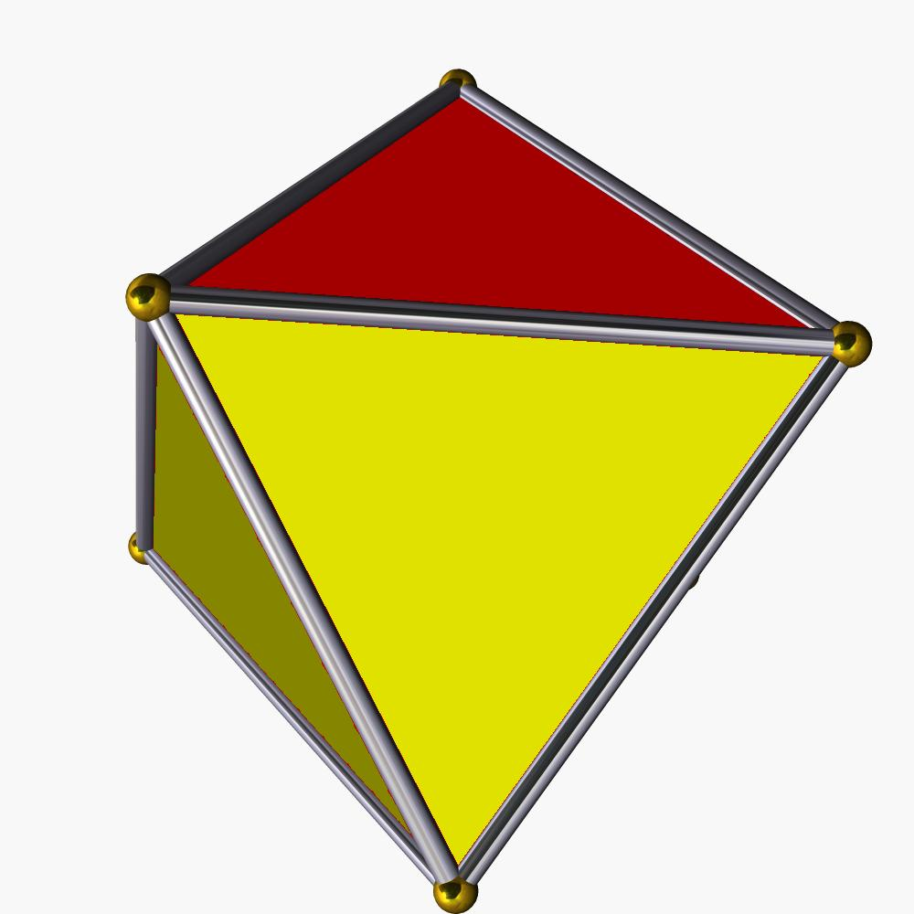

Square Antiprism
# Source: AI Source: Provided by: [Data Path: Persons Table -> ID Column: 1, Name_En Column: Motasem Essam] -> From: [ChatGPT] on [7/25/2026]
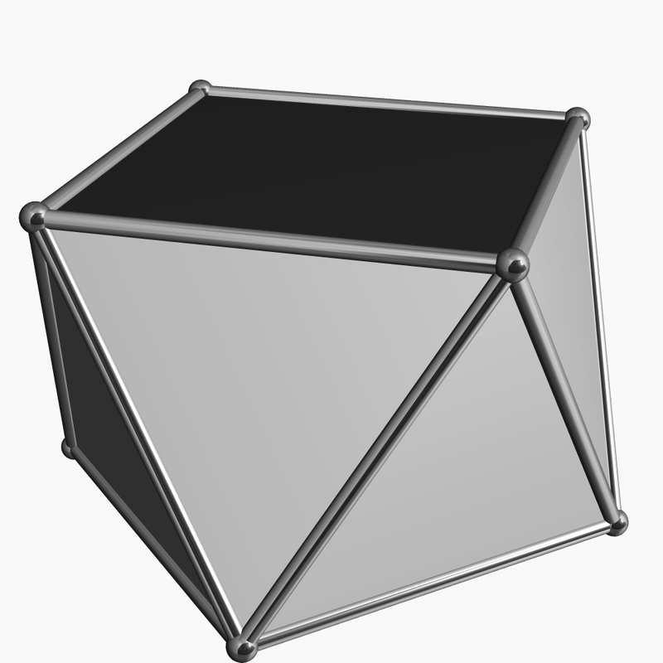

Pentagonal Antiprism
# Source: AI Source: Provided by: [Data Path: Persons Table -> ID Column: 1, Name_En Column: Motasem Essam] -> From: [ChatGPT] on [7/25/2026]
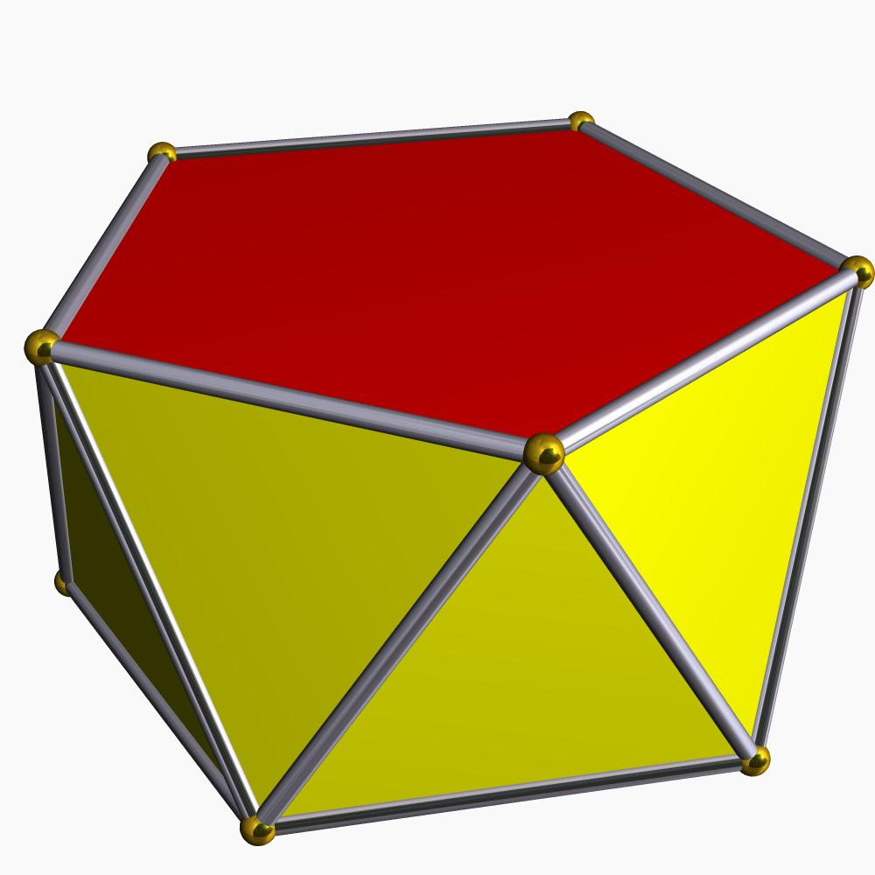

Hexagonal Antiprism
# Source: AI Source: Provided by: [Data Path: Persons Table -> ID Column: 1, Name_En Column: Motasem Essam] -> From: [ChatGPT] on [7/25/2026]

Heptagonal Antiprism
# Source: AI Source: Provided by: [Data Path: Persons Table -> ID Column: 1, Name_En Column: Motasem Essam] -> From: [ChatGPT] on [7/25/2026]
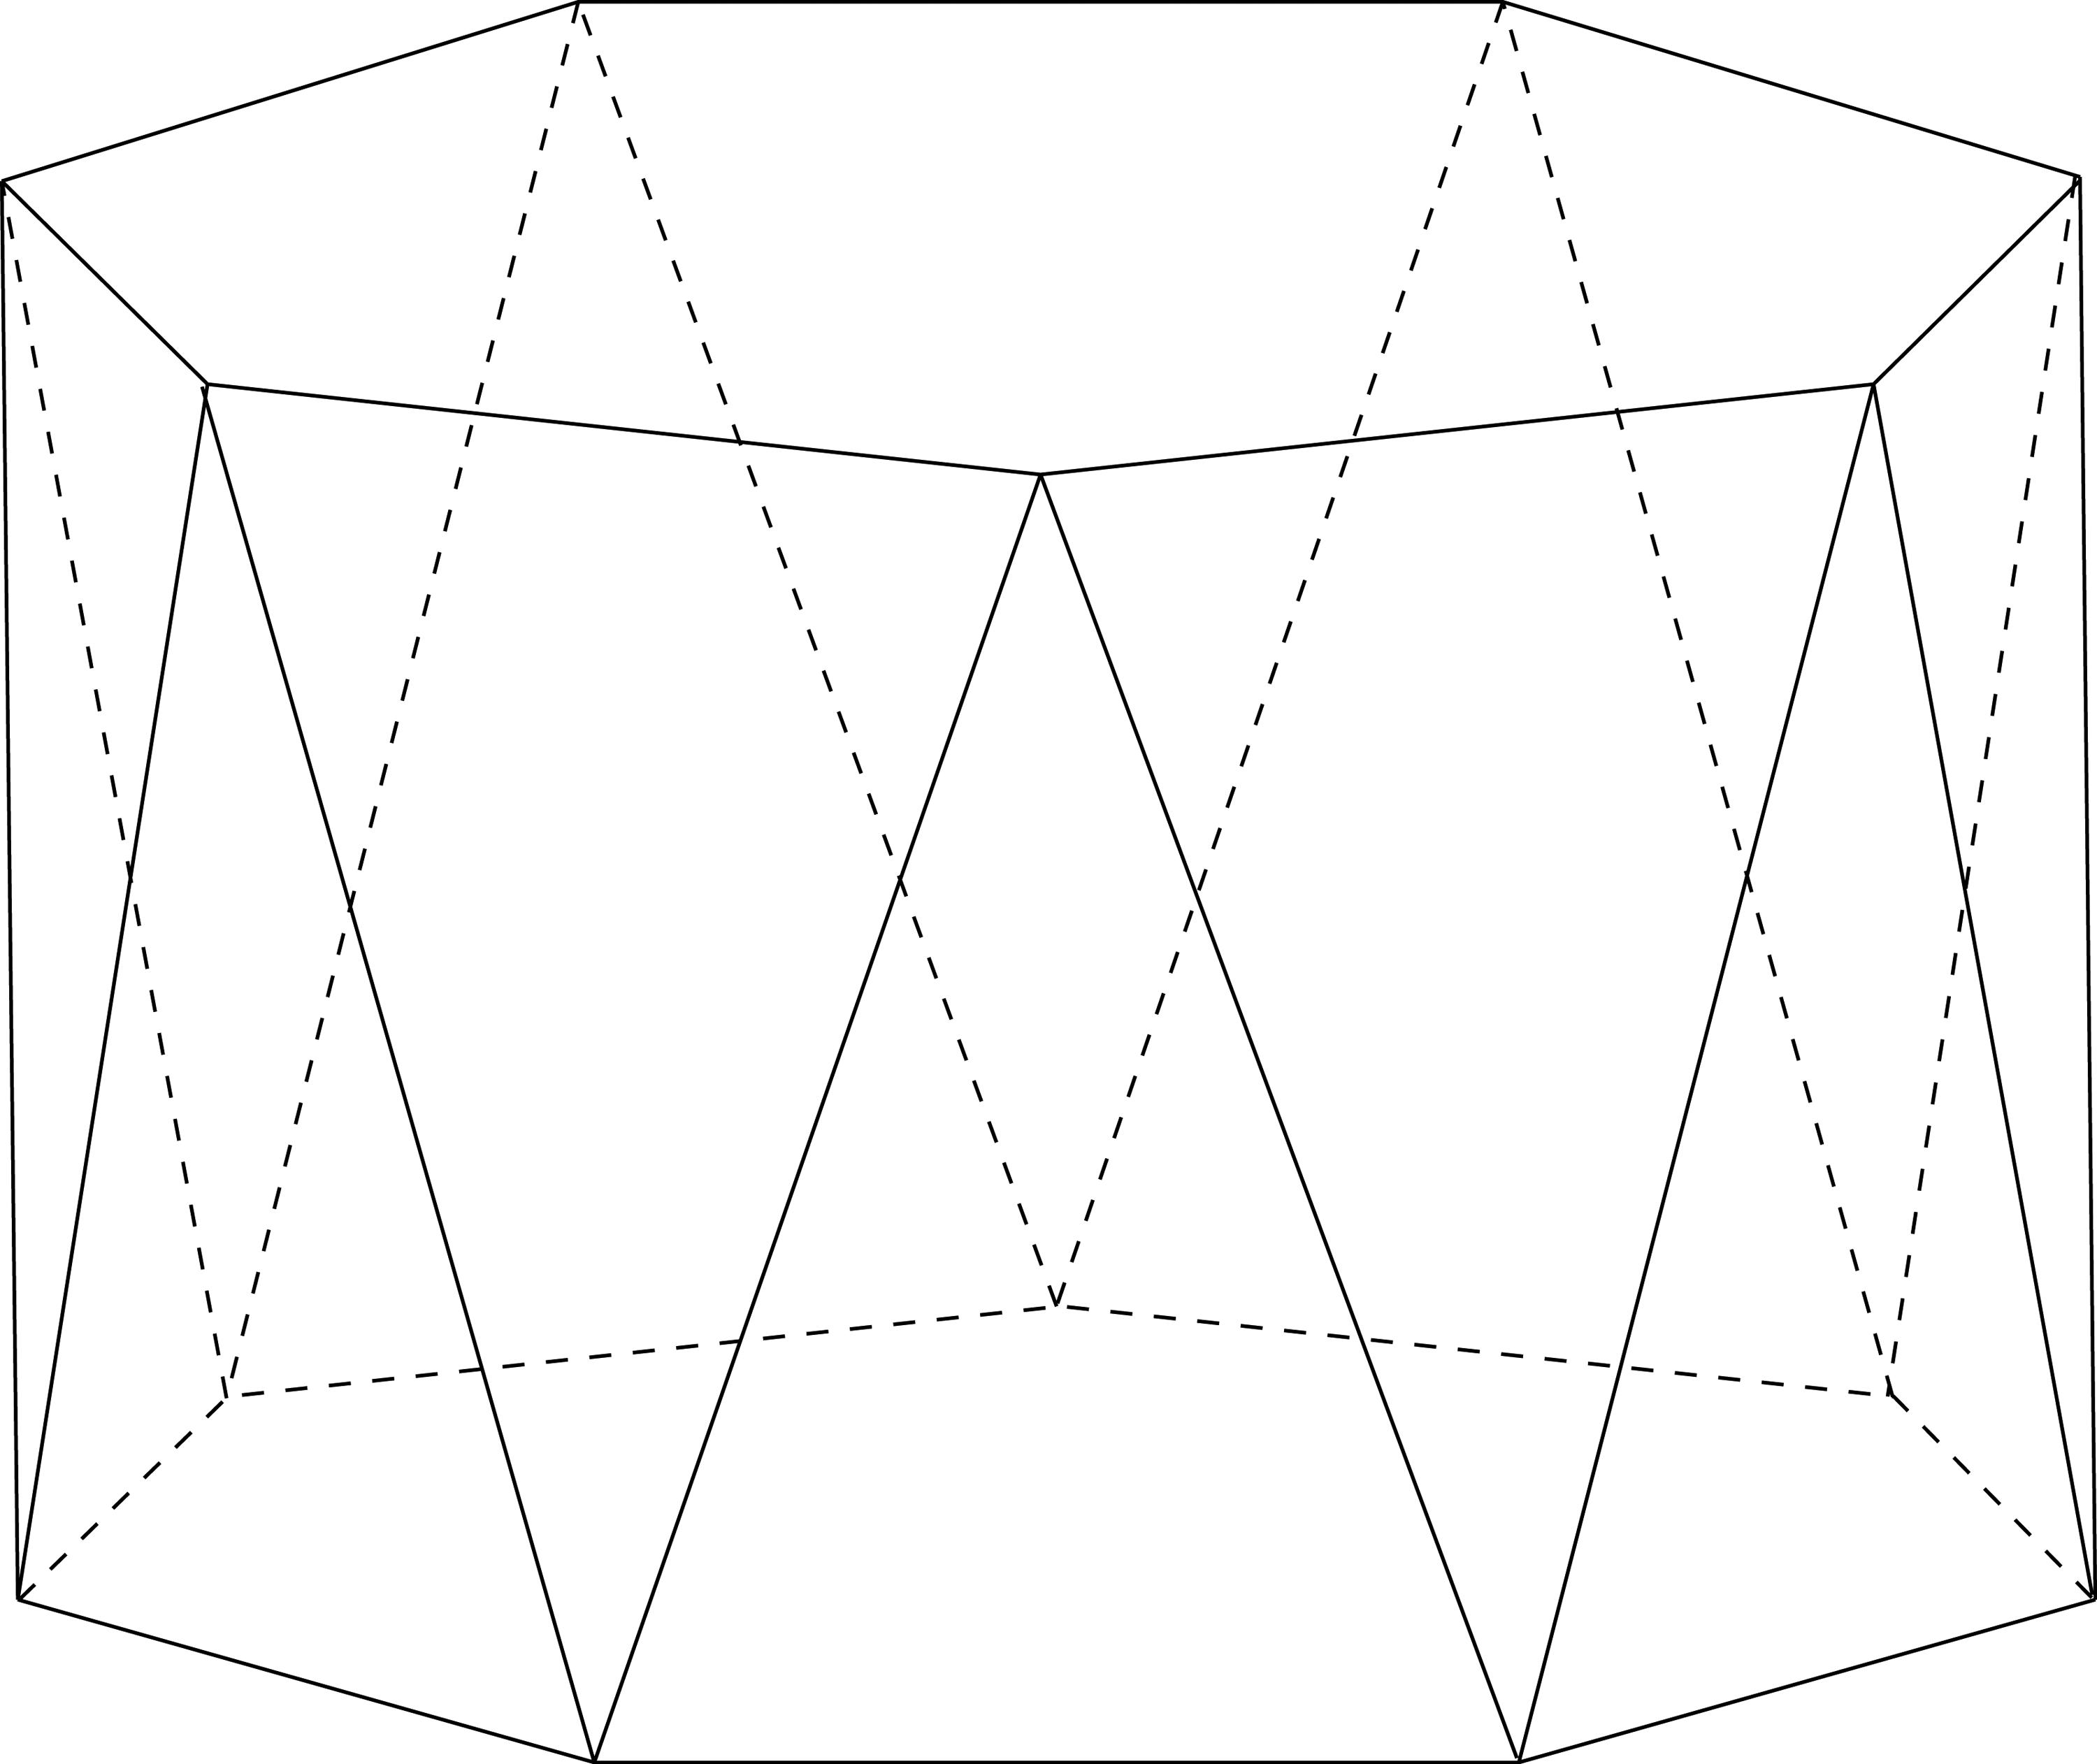

Octagonal Antiprism
# Source: AI Source: Provided by: [Data Path: Persons Table -> ID Column: 1, Name_En Column: Motasem Essam] -> From: [ChatGPT] on [7/25/2026]
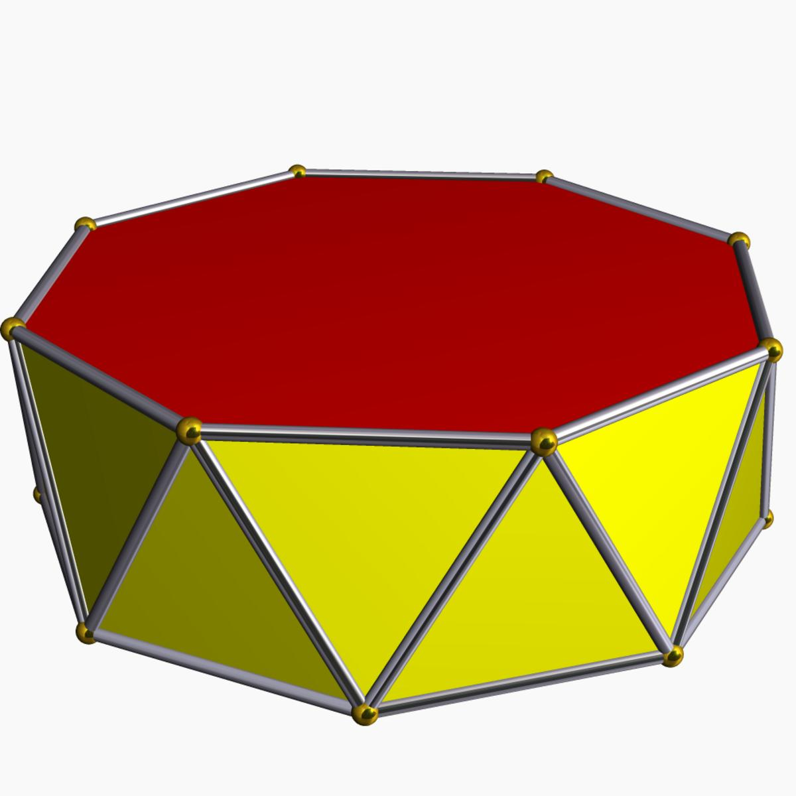
Other types include nonagonal, decagonal, and higher-order antiprisms.

Constructing Antiprism in Solid Geometry

Geometric Instruments Used
# Source: AI Source: Provided by: [Data Path: Persons Table -> ID Column: 1, Name_En Column: Motasem Essam] -> From: [ChatGPT] on [7/25/2026]
The construction uses traditional geometric instruments rather than coordinate-based construction.
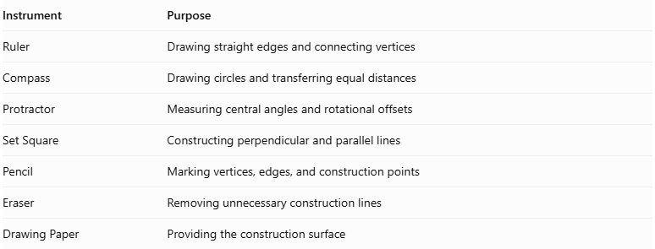
Instrument | Purpose
Ruler | Drawing straight edges and connecting vertices
Compass | Drawing circles and transferring equal distances
Protractor | Measuring central angles and rotational offsets
Set Square | Constructing perpendicular and parallel lines
Pencil | Marking vertices, edges, and construction points
Eraser | Removing unnecessary construction lines
Drawing Paper | Providing the construction surface

Instrument-Based Construction Procedures

Constructing the Lower Polygonal Base
# Source: AI Source: Provided by: [Data Path: Persons Table -> ID Column: 1, Name_En Column: Motasem Essam] -> From: [ChatGPT] on [7/25/2026]
- Draw a circle using a compass.
- Mark its center.
- Divide the circle into $n$ equal angular sections using a protractor.
- Calculate the central angle:
$$θ=\frac{{360}^{∘}}{n}$$
- Mark the $n$ equally spaced vertices around the circumference.
- Connect consecutive vertices using a ruler.
- Complete the lower polygonal base.

Constructing the Upper Polygonal Base
# Source: AI Source: Provided by: [Data Path: Persons Table -> ID Column: 1, Name_En Column: Motasem Essam] -> From: [ChatGPT] on [7/25/2026]
- Draw a second congruent polygon above the lower base.
- Keep the two base planes parallel.
- Apply a rotational offset to the upper polygon.
- For a standard regular antiprism, use a half-step rotation:
$$α=\frac{{180}^{∘}}{n}$$
- Ensure that the upper and lower bases have equal side lengths.
- Maintain the required perpendicular separation between the base planes.

Connecting the Two Bases
# Source: AI Source: Provided by: [Data Path: Persons Table -> ID Column: 1, Name_En Column: Motasem Essam] -> From: [ChatGPT] on [7/25/2026]
- Connect each upper-base vertex to the two neighboring lower-base vertices.
- Connect the lower-base vertices to the corresponding neighboring upper-base vertices.
- Arrange the connections in an alternating sequence.
- Form $2n$ triangular lateral faces.
- Check that the triangular faces form a continuous band around the solid.

Completing the Antiprism
# Source: AI Source: Provided by: [Data Path: Persons Table -> ID Column: 1, Name_En Column: Motasem Essam] -> From: [ChatGPT] on [7/25/2026]
- Verify that the upper and lower bases are congruent and parallel.
- Check that the rotational offset is consistent.
- Darken the visible external edges.
- Represent hidden edges using dashed lines when necessary.
- Remove unnecessary construction marks.
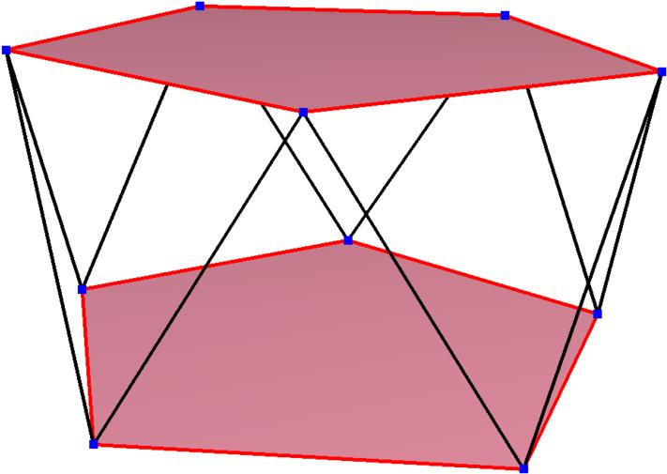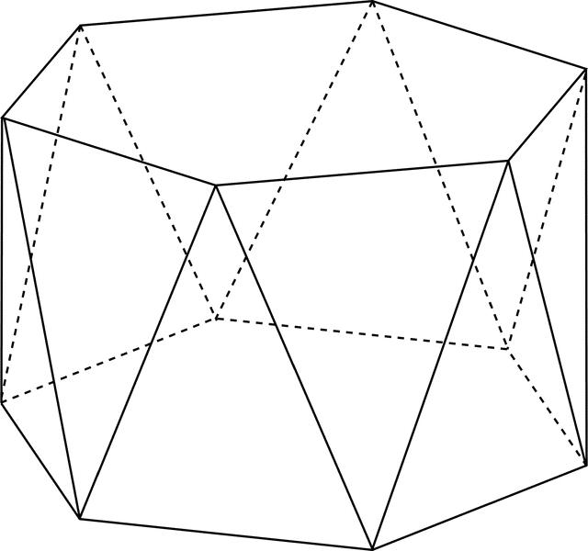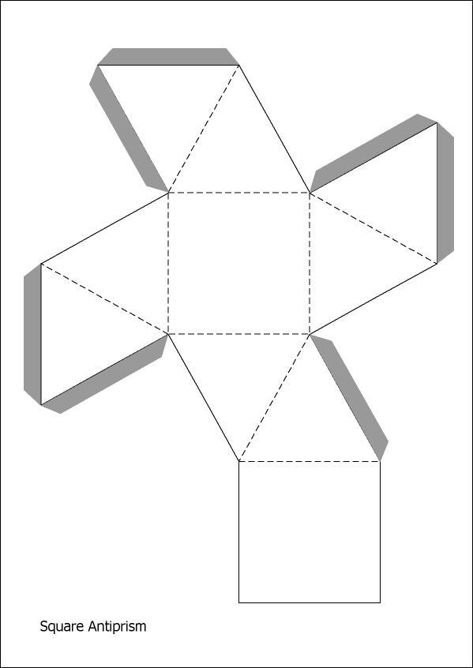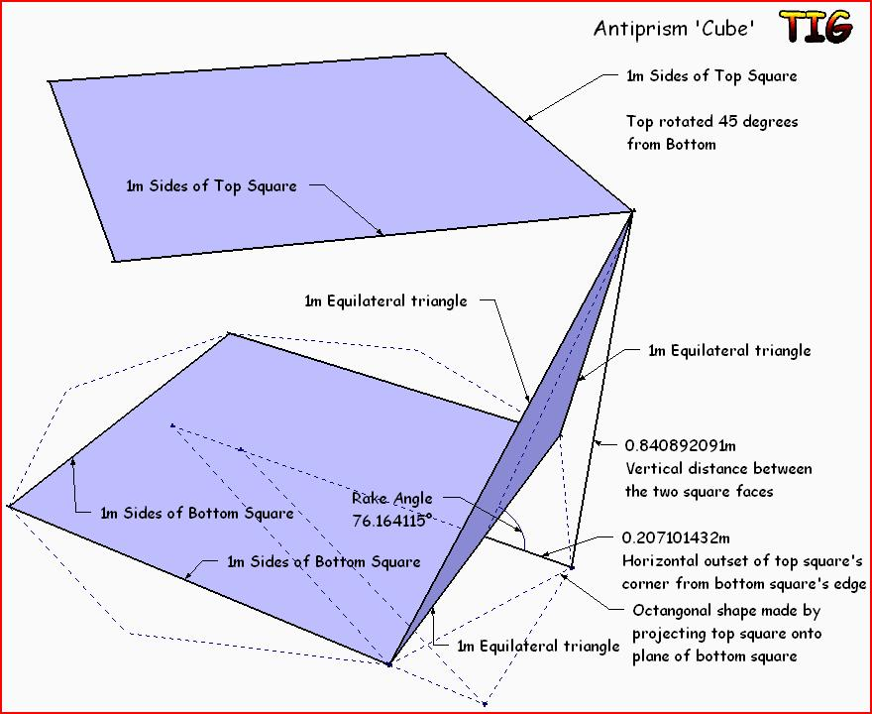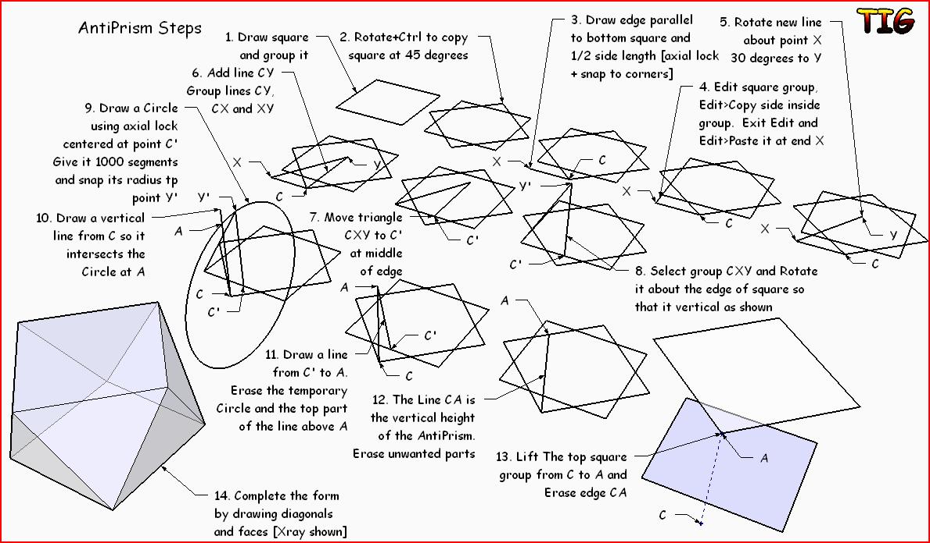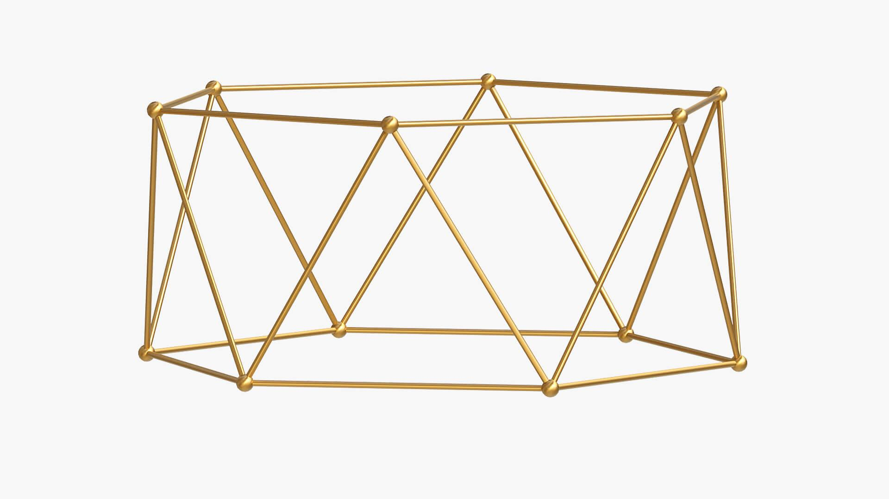

Key Points
# Source: AI Source: Provided by: [Data Path: Persons Table -> ID Column: 1, Name_En Column: Motasem Essam] -> From: [ChatGPT] on [7/25/2026]
- An antiprism has two parallel, congruent polygonal bases.
- The bases are rotated relative to each other.
- Its lateral surface consists of alternating triangular faces.
- An $n$-gonal antiprism has $2n+2$ faces, $4n$ edges, and $2n$ vertices.
- A triangular antiprism is a regular octahedron.
- A regular antiprism is a uniform polyhedron.
- Antiprisms differ from prisms because of their triangular lateral faces and twisted arrangement of bases.
Antiprism vs. Prism
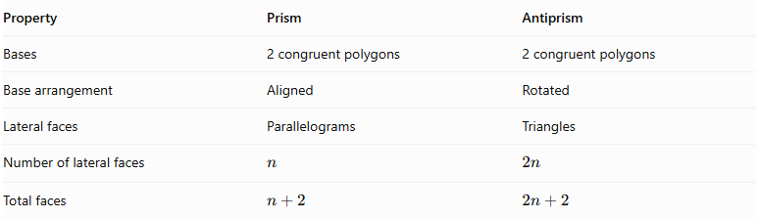
Property | Prism | Antiprism
Bases | 2 congruent polygons | 2 congruent polygons
Base arrangement | Aligned | Rotated
Lateral faces | Parallelograms | Triangles
Number of lateral faces | $$n$$ | $$2n$$
Total faces | $$n+2$$ | $$2n+2$$

Conclusion
# Source: AI Source: Provided by: [Data Path: Persons Table -> ID Column: 1, Name_En Column: Motasem Essam] -> From: [ChatGPT] on [7/25/2026]
An Antiprism is a polyhedron characterized by two parallel, congruent polygonal bases arranged with a relative rotation and connected by alternating triangular lateral faces. Its different types are classified according to the number of sides of their polygonal bases.

